Name: Sapargali Temirlan
Group: SE-2403
Instructor: Kozhakhmet Zhaksylyk
PART 3/4
TASK 5/6
Deriverables
All deliverables such as the contract files and e.t.c, are inside same directory as this document.
Vault tests:
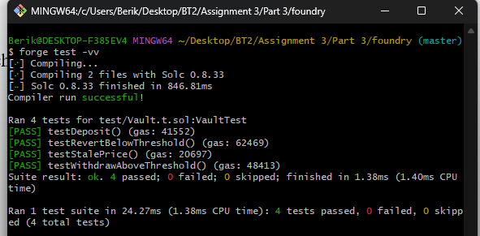

How The Graph decentralizes indexing vs traditional backend approaches
In traditional web and blockchain applications, data indexing is usually handled by centralized backend systems. In contrast, The Graph introduces a decentralized indexing protocol that changes how data from blockchains is collected, organized, and queried. The key difference lies in who performs the indexing work, how trust is established, and how resilient the system is.
In a traditional backend architecture, applications rely on centralized servers (often owned by a single company) to index and serve data. For example, in a typical web app, a backend might continuously scan a database, process incoming transactions, and store them in optimized tables for fast querying. If the system is blockchain-based, the backend often runs full nodes or uses RPC providers to read chain data, then transforms it into a database (like PostgreSQL or Elasticsearch). This approach is efficient but introduces clear trade-offs: the system is dependent on centralized infrastructure, prone to single points of failure, and requires trust in the entity operating the backend. If the service goes down, restricts access, or alters indexing logic, the application is directly affected.
The Graph replaces this model with a decentralized network of independent participants called indexers. Instead of one company controlling the indexing pipeline, many node operators compete and cooperate to index blockchain data. Developers define what data they need using subgraphs, which are open indexing specifications describing how to extract and organize data from smart contracts. These subgraphs are deployed to the network rather than a private backend.
When a query is made, it is routed through the network of indexers. Indexers process blockchain data, build indexes according to subgraph definitions, and respond to queries. They are incentivized economically—earning rewards for accurate indexing and query servicing, while being penalized for incorrect or malicious behavior. This creates a trust-minimized environment where correctness is enforced through cryptoeconomic mechanisms rather than corporate control.
A major architectural shift here is separation of concerns. In traditional systems, one backend controls ingestion, storage, and querying. In The Graph, these responsibilities are distributed:
Indexers process and serve data
Curators signal which subgraphs are valuable
Delegators support indexers by staking tokens
Consumers (applications) query data without needing their own indexing infrastructure
This separation improves scalability because many independent nodes can index the same blockchain data in parallel. It also improves resilience—there is no single backend that can be taken down. If one indexer fails, others continue serving data.
However, decentralization introduces trade-offs. Query latency may be higher than a tightly optimized centralized database. Coordination overhead is greater, and economic incentives must be carefully designed to ensure correctness and performance. Additionally, subgraph design becomes critical, since inefficient indexing logic can propagate across many indexers.
In summary, traditional backend indexing is centralized, tightly controlled, and efficient but fragile. The Graph decentralizes indexing by distributing it across a network of economically incentivized participants, replacing trust in a single operator with cryptographic and game-theoretic guarantees. This makes it particularly well-suited for blockchain environments where openness, censorship resistance, and fault tolerance are core requirements.

